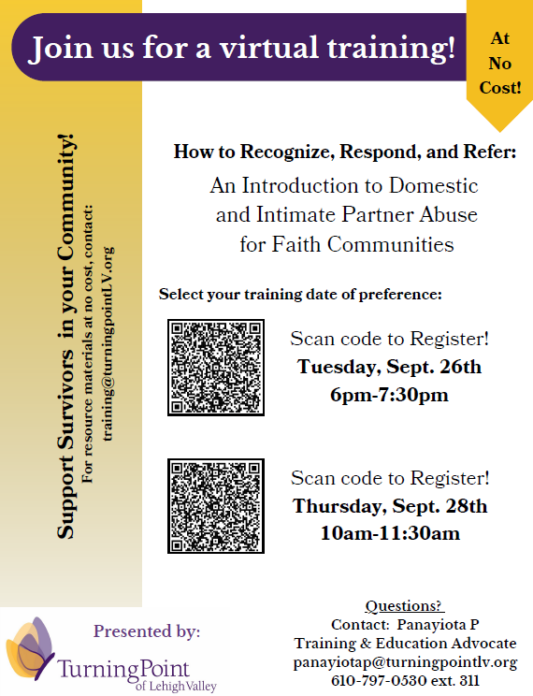
Turning Point of Lehigh Valley has been in connection with the Interfaith Action Committee for the last year in an effort to support survivors of domestic and intimate partner abuse. Through discussion and collaboration with the leaders of faith-based communities, we hope to continue our mission of eliminating domestic and intimate partner abuse within the Lehigh Valley through survivor empowerment, community education, and engagement.
Faith, spirituality, and faith-based communities can often be an integral piece of the supportive puzzle for our survivors; however, they can also keep survivors further isolated in the shadows. Faith leaders and community members can be a vital part of a survivor’s healing journey.

This upcoming faith based training (details in flyer on top left) will help build awareness and train your faith leaders
and community members to recognize warning signs of those in abusive relationships, provide awareness education on the scope of the issue, and guide participants how to safely refer clients, colleagues, friends, and family to local resources in a trauma-informed and survivor centered-way.
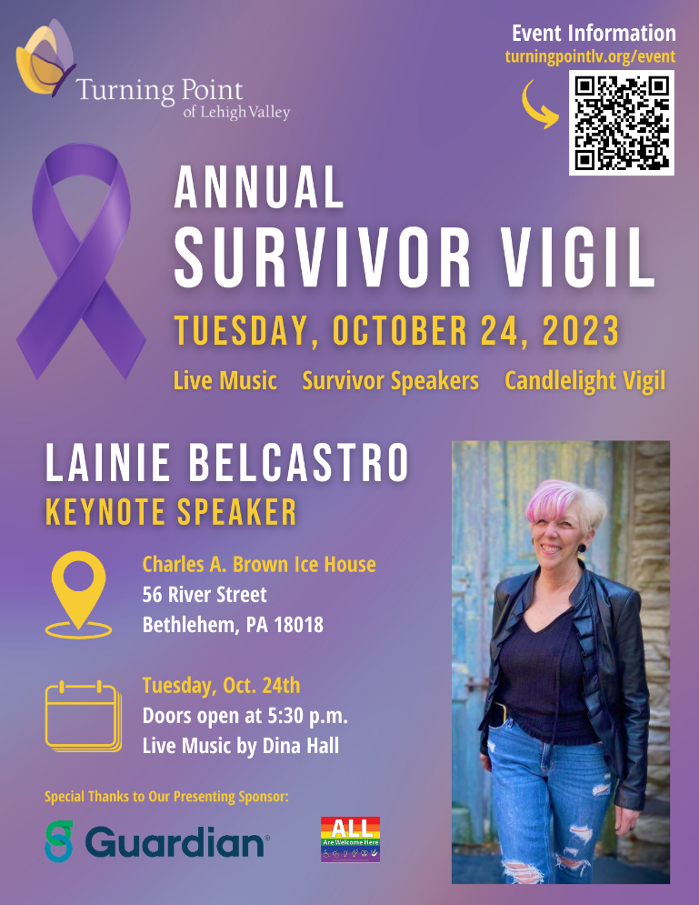
Additionally, another way for members of the faith community to get involved and help empower their members through awareness education is to join us for our Annual Survivor Vigil (details on bottom right). This happens every October, in honor of Domestic Violence Awareness Month. The vigil provides both the time and safe space to honor in memory those who have lost their lives to domestic and intimate partner abuse. We also seek to educate, empower, and encourage participants through highlighted voices of survivor speakers, survivor art, live music, and light refreshments.
If you have any questions or would like to request any of our referral materials, or an educational training for your faith community, business, or organization, please contact our Training and Education team at training@turningpointlv.org.

If you or someone you know needs help with a domestic or intimate partner abuse situation in Lehigh or Northampton Counties, please reach out to our 24/7 helpline at: 610-437-3369 / Toll-free: 877-438-4957 / TTY: 610-419-4594. www.turningpointlv.org.

